Abhra~2
Monthly sales of U.S. houses (thousands) 1965 - 1975. Source: Abraham & Ledolter (1983).
(132 observations)
38 | 41 | 64
44 | 40 | 63
53 | 32 | 63
49 | 32 | 72
54 | 34 | 61
57 | 40 | 65
51 | 43 | 51
58 | 42 | 47 | 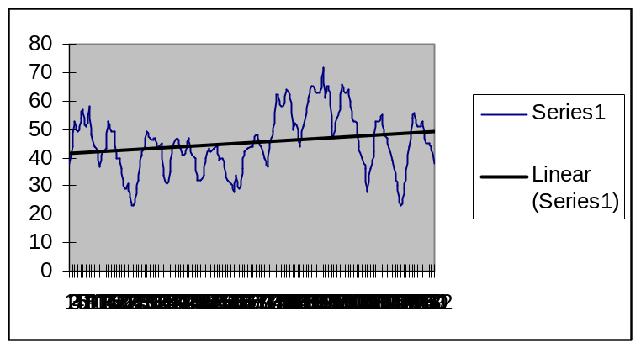
48 | 43 | 54
44 | 44 | 58
42 | 39 | 66
37 | 40 | 63
42 | 33 | 64
43 | 32 | 60
53 | 31 | 53
49 | 28 | 52
49 | 34 | 44
40 | 29 | 40
40 | 36 | 36
36 | 42 | 28
29 | 43 | 36
31 | 44 | 42
26 | 44 | 53
23 | 48 | 53
29 | 45 | 55 |  |  | Analysis | Y/N
32 | 44 | 48 |  |  | Trend :
41 | 40 | 47 |  |  | Cycle :
44 | 37 | 43 |  |  | Seasonal:
49 | 45 | 39
47 | 49 | 33
46 | 62 | 30
47 | 62 | 23
43 | 58 | 29
45 | 59 | 33
34 | 64 | 44
31 | 62 | 54
35 | 50 | 56
43 | 52 | 51
46 | 50 | 51
46 | 44 | 53
43 | 51 | 45
41 | 56 | 45
44 | 60 | 44
47 | 65 | 38

Abraham~1
Monthly gasoline demand Ontario gallon millions 1960 - 1975. Source: Abraham & Ledolter (1983).
(192 obsevations)

87695 | 130931 | 162312 | 158167
86890 | 137018 | 167211 | 156261
96442 | 121271 | 172897 | 176353
98133 | 123548 | 189689 | 175720
113615 | 109894 | 166496 | 193939
123924 | 106061 | 160754 | 201269
128924 | 112539 | 155582 | 218960
134775 | 125745 | 145936 | 209861
117357 | 136251 | 139625 | 198688
114626 | 140892 | 137361 | 190474
107677 | 158390 | 138963 | 194502
108087 | 148314 | 155301 | 190755
92188 | 144148 | 172026 | 166286
88591 | 140138 | 165004 | 170699
98683 | 124075 | 185861 | 181468
99207 | 136485 | 190270 | 174241
125485 | 109895 | 163903 | 210802
124677 | 109044 | 174270 | 212262
132543 | 122499 | 160272 | 218099
140735 | 124264 | 165614 | 229001
124008 | 142296 | 146182 | 203200
121194 | 150693 | 137728 | 212557
111634 | 163331 | 148932 | 197095
111565 | 165837 | 156751 | 193693
101007 | 151731 | 177998 | 188992
94228 | 142491 | 174559 | 175347
104255 | 140229 | 198079 | 196265
106922 | 140463 | 189073 | 203526
130621 | 116963 | 175702 | 227443
125251 | 118049 | 180097 | 233038
140318 | 137869 | 155202 | 234119
146174 | 127392 | 174508 | 255133
122318 | 154166 | 154277 | 216478
128770 | 160227 | 144998 | 232868
117518 | 165869 | 159644 | 221616
115492 | 173522 | 168646 | 209893
108497 | 155828 | 166273 | 194784
100482 | 153771 | 190176 | 189756
106140 | 143963 | 205541 | 193522
118581 | 143898 | 193657 | 212870
132371 | 124046 | 182617 | 248565
132042 | 121260 | 189614 | 221532
151938 | 138870 | 174176 | 252642
150997 | 129782 | 184416 | 255007

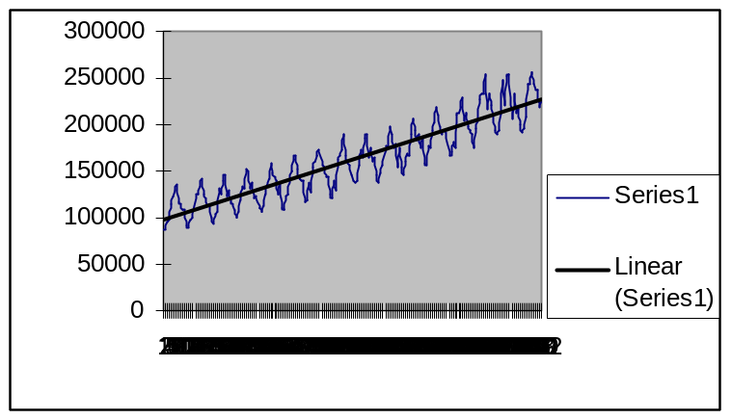

Analysis Y/N
Trend
Cycle
Seasonal

Djweek.dat
WEEKLY CLOSINGS OF THE DOW-JONES INDUSTRIAL AVERAGE, July 1971-Aug 2, 1974
#JULY 1971 THROUGH 2 AUGUST 1974. DATA QUOTED IN UNPUBLISHED PAPER BY D.
#A. HSU, TAKEN FROM "NEW YORK STOCK EXCHANGE: STOCK PRICES", PUBLISHED
#QUARTERLY BY STANDARD AND POOR CO., NEW YORK, N.Y.

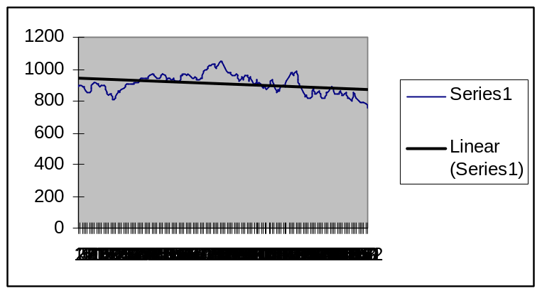
890.19 | 962.6 | 1039.36 | 963.73
901.8 | 967.72 | 1026.19 | 987.06
888.51 | 963.8 | 1003.54 | 935.28
887.78 | 954.17 | 980.81 | 908.42
858.43 | 941.23 | 979.46 | 891.33
850.61 | 941.83 | 979.23 | 854
856.02 | 961.54 | 959.89 | 822.25
880.91 | 971.25 | 961.32 | 838.05
908.15 | 961.39 | 972.23 | 815.65
912.75 | 934.45 | 963.05 | 818.73
911 | 945.06 | 922.71 | 848.02
908.22 | 944.69 | 951.01 | 880.23
889.31 | 929.03 | 931.07 | 841.48
893.98 | 938.06 | 959.36 | 855.47
893.91 | 922.26 | 963.2 | 859.39
874.85 | 920.45 | 922.19 | 843.94
852.37 | 926.7 | 953.87 | 820.4
839 | 951.76 | 927.89 | 820.32
840.39 | 964.18 | 895.17 | 855.99
812.94 | 965.83 | 930.84 | 851.92
810.67 | 959.36 | 893.96 | 878.05
816.55 | 970.05 | 920 | 887.83
859.59 | 961.24 | 888.55 | 878.13
856.75 | 947.23 | 879.82 | 846.68
873.8 | 943.03 | 891.71 | 847.54
881.17 | 953.27 | 870.11 | 844.81
890.2 | 945.36 | 885.99 | 859.9
910.37 | 930.46 | 910.9 | 834.64
906.68 | 942.81 | 936.71 | 845.9
907.44 | 946.42 | 908.87 | 850.44
906.38 | 984.12 | 852.38 | 818.84
906.68 | 995.26 | 871.84 | 816.65
917.59 | 1005.57 | 863.49 | 802.17
917.52 | 1025.21 | 887.57 | 853.72
922.79 | 1023.43 | 898.63 | 843.09
942.43 | 1033.19 | 886.36 | 815.39
939.87 | 1027.24 | 927.9 | 802.41
942.88 | 1004.21 | 947.1 | 791.77
942.28 | 1020.02 | 971.25 | 787.23
940.7 | 1047.49 | 978.63 | 787.94

Analysis Y/N
Trend
Cycle
Seasonal

********* 9-17b.dat Sample dataset **********

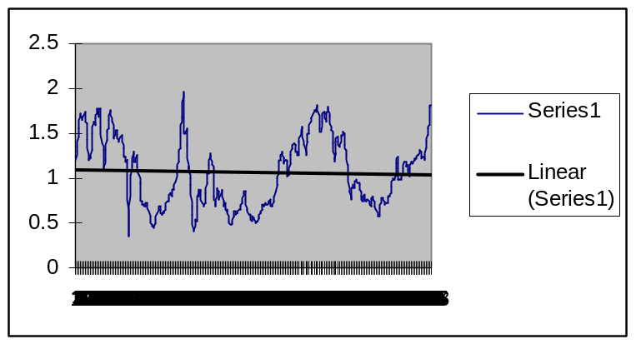

Analysis Y/N
Trend
Cycle
Seasonal

*******************************************************

******** No. of acres burned in forest fires in CANADA (excl. Yukon & NWT) 1918-1988 *******
canfire.dat sample dataset

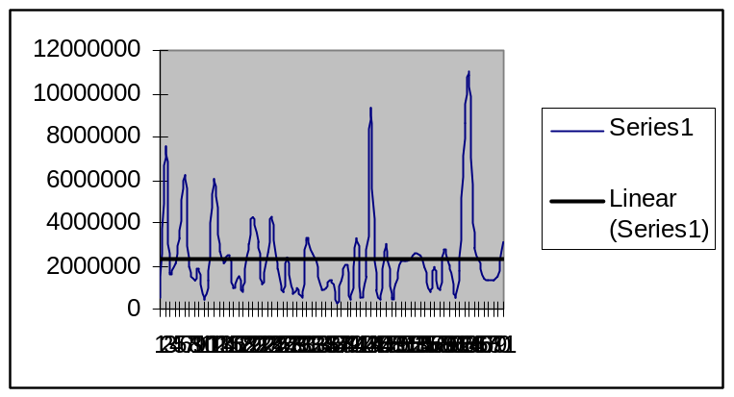

Analysis Y/N
Trend
Cycle
Seasonal

*******************************************************

